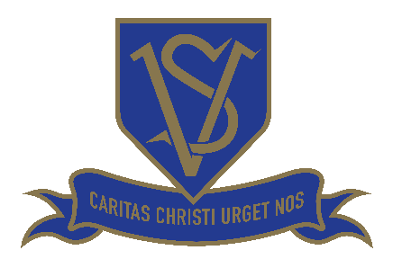

St Vincent’s Nursery - Fees

Funded hours

15 hours
Your child is eligible for 15 hours per week of funded ‘free childcare entitlement’ (paid for by London Borough of Barnet). This funding starts from the term after they turn 3 years old.
Our sessions are;
- 08:45 – 11:45
- Lunch 11:45 – 12:30 (Please note there is a charge of £10.00 for lunch time sessions – food not included)
- 12:30 – 15:30

30 hours
We do also offer a limited number of funded places for parents who meet the criteria for 30 hours of ‘free entitlement’ per week. Please contact us for further information if required.
The sessions are;
- 09:30-15.30
- Early start session: 08:45 – 09:30 (Please note there is a charge of £10.00 for this session)

Additional non-funded hours
If you wish for your child to attend any sessions in addition to your funded hours, the cost will be as follows;
Fees (as of September 2026) are;
- £36.00 per session (am or pm)
- £10.00 per lunch time session
- £10.00 per early start session
The times for these additional sessions are;
- 08:45 – 11:45
- 12:30 – 15:30
Please note: If you purchase additional hours, payment of fees is termly in advance. In order to receive a funded place for a child, parents/carers are required to complete and sign a Parental Contract/Declaration. If you wish to make a change to your booked sessions, a term’s notice is required.
Ad hoc charges: costs for voluntary items, such as class trips will be communicated to all parents.
Charges may be incurred for any late pick-ups.

